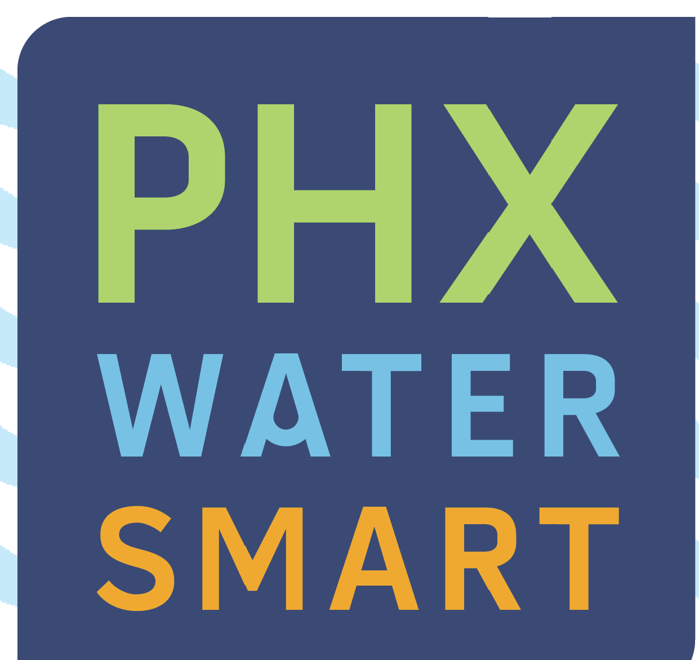
2 0 1 7
Water
Quality Report
T
he city of Phoenix is committed to providing the highest quality tap water and reliable services to our
residents, with rates that are among the lowest in the country. This Consumer Confidence Report, als
o known
as a Water Quality Report, summarizes the results of millions of tests and measurements performed at Phoenix's
water treatment plants and throughout the water distribution system. In 2017, tap water delivered to approximately
1.5 million residents served by the City of Phoenix Water Services Department met or surpassed all federal and state drinking water standards.

Presented by
To acquire this publication in an alternate format, contact the City of Phoenix Water Services Department at 602-262-6251, or 711 for Telecommunications Relay Services.

Este informe contiene información importante sobre su agua potable. Si desea esta publicación en español, o en un formato alterno contactan el Departamento Municipal de Phoenix del Servicio del Agua, al 602-262-6251, ó 711/TTY.

Where Does Our Water Come From?
he sources of Phoenix’s drinking water include rivers, lakes, streams, springs and wells. In 2017, about 98 percent of Phoenix’s water came from surface water that mostly started as snow pack. Phoenix’s primary sources of untreated surface
T

phoenix.gov/water
water are the Salt, Verde and Colorado rivers. Some water from the Agua Fria River is mixed with water from the Colorado River when stored in Lake Pleasant. The water is then delivered to one of the city’s five water treatment plants. Colorado River water is delivered to the city via the Central Arizona Project (CAP) aqueduct. Water from the Salt and Verde rivers is delivered via the Salt River Project (SRP) canal network. The remaining two percent of drinking water was supplied by about 20 groundwater wells currently operated by the city.

HOW DOES PHOENIX PRODUCE SUPERIOR DRINKING WATER?
2
4
1
3
- Screening and Presedimentation - Large particles such as plant matter debris, and other materials commonly found in river water are removed by screens or settle to the bottom of the presedimentation tank.
- Coagulation, Flocculation and Sedimentation - A chemical coagulant, such as ferric chloride, is added to the water. This causes the tiny particles to cling together and become heavy enough to settle to the bottom of the basin.
- Filtration - The cleaner water on the top then passes through filters to remove remaining particulate matter.
- Disinfection -A small quantity of chlorine, a disinfectant, is added to prevent microbial growth. Also a small quantity of fluoride is added to prevent tooth decay.

Water Quality and Substances Contained in Source Water

o ensure that tap water is safe to drink, the U.S. Environmental Protection Agency (EPA) prescribes regulations that limit the amount
T
of certain contaminants in water provided by public water systems. The U.S. Food and Drug Administration (FDA) regulations establish limits for contaminants in bottled water.
It is reasonable to expect drinking water, including bottled water or water that passed through home treatment systems, to contain at least small amounts of some contaminants. As water travels over the surface of the land or through the ground, it dissolves naturally-occurring minerals and, in some cases, radioactive material, and can pick up substances resulting from the presence of animals or from human activity. However, the presence of contaminants does not necessarily indicate that water poses a health risk. Contaminants that may be present in source water include the following:
- Microbial contaminants, such as viruses and bacteria, that may be from wastewater treatment plants, septic systems, agricultural livestock operations, or wildlife;
- Inorganic contaminants, such as salts and metals, that can be naturally-occurring or result from urban storm water runoff, industrial or domestic wastewater discharges, oil and gas production, mining, or farming;
- Pesticides and herbicides, that may come from a variety of sources such as agriculture, urban storm water runoff and residential uses;
Connect with Us!
phoenix.gov/water

/PHXWater

@PHXWater

/PHXWater
- Organic chemical contaminants, including synthetic and volatile organic chemicals, that are byproducts of industrial processes, petroleum production, and can also come from gas stations, urban storm water runoff, septic systems; and
- Radioactive contaminants that can be naturally-occurring or can be the result of oil and gas production and mining activities.
More information about contaminants and potential health effects can be obtained by calling the EPA Safe Drinking Water Hotline, 800-426- 4791. Information on bottled water can be obtained from the U.S. Food and Drug Administration.

Phoenix Monitors for Unregulated Contaminants
U
nregulated substances are those for which EPA has not established drinking water standards. Phoenix monitors for these substances to
assist the EPA in determining the occurrence of unregulated contaminants in drinking water and whether future regulation is warranted. The EPA issues a new list of up to 30 unregulated substances for monitoring every five years.
EPA identified 27 substances for monitoring during this five year cycle including:
- 14 compounds found in products such as firefighting foams, cosmetics, cleaners, paints, adhesives, industrial solvents and insecticides
- 4 metals that occur naturally in our environment
- 7 hormones, including naturally-occurring hormones that may also be present in pharmaceuticals and personal care products
- The chlorate ion that may be present in drinking water when certain disinfectants are added to water to kill microbes
- The chromium-6 ion, a naturally-occurring element with industrial uses.
EPA currently regulates total chromium in drinking water. The maximum contaminant level for total chromium was established based upon the health effects of chromium-6, but when analyzing for total chromium the amount measured is the sum of all chromium ions present (chromium-6 and chromium-3). EPA is gathering information to determine the relationship between the amount of total chromium and chromium-6 present in drinking water. For this reason, EPA is requesting sample sets of the regulated substance (total chromium) and unregulated substance (chromium-6) be collected at the same time.
From February of 2013 through August 2015, the City monitored for unregulated substances. Any unregulated contaminants detected are reported in the following table. There is a naturally-occurring chromium deposit in northern Phoenix near several wells sites. Water from these wells currently meets the EPA standard for total chromium. If the EPA determines that regulation is warranted for any of the monitored substances, Phoenix will take whatever steps are necessary to comply with the new requirements.

Controlling Disinfectants and Disinfection Byproducts
P
hoenix’s entire water supply (well water and treated surface water) is safely disinfected with chlorine before being delivered
to consumers. Federal law requires a minimum chlorine disinfectant level of 0.2 parts per million (ppm) in the water leaving a water treatment plant. There also is a Maximum Residual Disinfectant Level (MRDL) allowed in the water in the distribution system as it travels to your tap.
While it is essential to disinfect the water to prevent widespread outbreaks of serious diseases and comply with EPA standards, the use of disinfectants can create disinfection byproducts (DBPs), which are formed when natural organic matter such as total organic carbon (TOC) in water reacts with chemicals used for disinfection.
To control those DBPs, TOC is measured in the surface water before and after treatment. TOC is reduced during the water treatment process at the plant, therefore, reducing formation of DBPs in the distribution system. Compliance for TOC is based on the removal ratio of TOC on a running annual average. A value of 1 or greater indicates the water treatment plant is in compliance with the TOC removal requirements. Again, Phoenix met the requirement, as shown in the corresponding chart.
Chlorine dioxide and ozone can be used in the treatment of drinking water as either disinfectants or oxidants. Some Phoenix surface water treatment plants use chlorine dioxide and/or ozone as oxidants for the removal of iron and manganese, destruction of taste and odor causing organic contaminants, and as part of an overall program for the control of Trihalomethanes (THMs) formation. Federal law allows a maximum chlorine dioxide level of 800 parts per billion (ppb) in the water leaving a water treatment plant. Chlorine dioxide is measured daily at the water treatment plants when chlorine dioxide is in use, and levels are consistently below 800 ppb.
Using chlorine dioxide forms chlorite and using ozone forms bromate. Chlorite and bromate are regulated as DBPs. To determine formation of DBPs from oxidants, chlorite is sampled daily at the entry

*Unregulated Contaminants
Substance | Units | MCL | Lowest Level | Highest Level | Average | Major Source in Drinking Water
Molybdenum | ppb | None | 1.3 | 1.6 | 1.5 | Naturally-occurring element found in ores and present in plants, animals and bacteria; commonly used form molybdenum trioxide used as a chemical reagent.
Strontium | ppb | None | 520 | 540 | 530 | Naturally-occurring element; historically, commercial use of strontium has been in the faceplate glass of cathode ray tube televisions to block x-ray emissions.
Vanadium | ppb | None | 14 | 16 | 15 | Naturally-occurring elemental metal; used as vanadium pentoxide which is a chemical intermediate and a catalyst
Chlorate | ppb | None | 52 | 440 | 246 | Agricultural defoliant or desiccant; disinfection byproduct; and used in production of chlorine dioxide.
Chromium, Total | ppb | 100 | Surface water (98% of Phoenix’s water) |  |  | Naturally-occurring element; used in making steel and other alloys; chromium-3 or chromium-6 forms are used for chrome- plating, dyes and pigments, leather tanning and wood preservation.
 |  |  | ND | 1.7 | 0.4
 |  |  | Ground water (2% of Phoenix’s water)
 |  |  | 3.7 | 6.4 | 5.1
 |  |  | Distribution Sites
 |  |  | 0.2 | 1.7 | 0.5
Chromium-6 | ppb | None | Surface water (98% of Phoenix’s water) |  |  | Naturally-occurring element; used in making steel and other alloys; used for chrome- plating, dyes and pigments, leather tanning and wood preservation.
 |  |  | ND 1.6 |  | 0.35
 |  |  | Ground water (2% of Phoenix’s water)
 |  |  | 2.9 | 6.2 | 4.6
 |  |  | Distribution Sites
 |  |  | 0.1 | 1.6 | 0.4
The next round of monitoring for a new set of unregulated contaminants as required by the EPA began in January 2018. *Monitoring occurred 2013-2015.

2017 Disinfectant and Disinfection Byproduct Monitoring

Substance | Units | MCL | MCLG | Sample Results Range | Highest Running Annual Average | Major Source in Drinking Water
Chlorine | ppm | MRDL = 4  Running Annual Average | MRDLG = 4 | ND – 2.8 | 0.9 | Water additive used to control microbes
Total Organic Carbon Removal Ratio | NA | TT = 1 or greater Running Annual Average | NA | 1.0 – 3.5 | 1.5  (lowest running annual average) | Naturally present in the environment
Chlorine Dioxide | ppb | MRDL = 800 | MRDLG  = 800 | ND - 380 | NA | Water additive as an oxidant
Chlorite | ppm | 1 | 0.8 | ND - 0.7 | 0.3  (highest quarterly average) | Byproduct of drinking water treatment
Total Trihalomethanes (TTHMs) | ppb | 80  Locational Running Annual Average | NA | 18 - 87 | 64 | Byproduct  of drinking water disinfection
Haloacetic Acids (HAA) | ppb | 60  Locational Running Annual Average | NA | 6 - 32 | 22 | Byproduct  of drinking water disinfection
point of the distribution system, and quarterly throughout the distribution system. Bromate is sampled monthly at the entry point to the distribution system. The chlorite results were below the MCL and the bromate was not detected.
To determine formation of DBPs from chlorine in the distribution system, the city monitors for THMs and Haloacetic Acids (HAAs) which are DBPs that may cause long-term health effects at certain concentrations. THMs and HAAs are sampled throughout the distribution system every calendar quarter. The LRAA for all samples collected at the monitoring locations throughout the distribution system were below the MCL.

aste, odor and hardness are not regulated under drinking water health standards. However, these are
Taste, Odor and Hardness
T
harmless, aesthetic aspects that some consumers may notice.
Algae that grow in the canals during the late summer and fall are a major source of a “musty” odor and taste detected by some consumers. When the algae bloom, they produce a strong odor. Even though the algae are removed from the water during the treatment process, the odor may linger. The result is similar to removing a bouquet of fresh flowers from a room. Even though the flowers are gone, the aroma remains.
The city of Phoenix is working to eliminate the aesthetic
effects of algae through various programs, including a cooperative effort to remove algae from the SRP canals that feed the water treatment plants, and the use of activated carbon to absorb residual odors.
Water hardness indicates the presence of minerals, such as calcium and magnesium, which originate from the soils our source water contacts as it travels to Phoenix’s water treatment plants. These minerals are leached into the water. Hard water can cause some types of scaling in pipes and water heaters, and on plumbing fixtures such as faucets and showerheads. See the chart below for data about hardness and other aesthetic parameters.
Where to Learn More About the Quality of Our Water
I
f you have questions about this report,
concerns about water quality, or input about your water supply, treatment and delivery, email watersmart@phoenix.gov or call Phoenix Water Services’ Environmental Services Division at 602-262-5012 Monday through Friday, except holidays, from 7:30 a.m. to 4:00 p.m., or write to: “Water Quality Questions,” c/o City of Phoenix Water Services Department, Environmental Services Division, 2474 South 22nd Avenue, Building 31, Phoenix AZ 85009.
Citizens who wish to address the Phoenix City Council about water issues or other
non-agenda items may do so at the Citizen Request Sessions at City Council Formal meetings, which are held in the City Council Chambers, 200 W. Jefferson St. For information about specific meeting times and agenda items, please contact the City of Phoenix City Clerk Department at
602-262-6811, or visit phoenix.gov and click on Mayor/City Council, City Meetings, and Public Meetings.
For alternate formats, contact Customer Services at 602-262-6251/Voice, or 711 for Telecommunication Relay Services.
You also can visit the city’s web site at phoenix.gov for more information. An online version of this report is available at phoenix.gov/waterservices/waterquality.
You also may call the EPA’s Safe Drinking Water Hotline for information about the Safe Drinking Water Act or EPA’s other drinking
water programs at 800-426-4791.

2017 Aesthetic Water Quality Analysis from Distribution System and Secondary Drinking Water Guidelines
Substance | Units | Secondary Guideline * | Sample Results Range
Alkalinity | ppm | NA | 82 - 161
Iron | ppb | 300 | ND - 25
pH | NA | 6.5 - 8.5 | 7.6 - 8.0
Sodium | ppm | NA | 25 - 264
Temperature | ºF | NA | 56 - 94
Total Dissolved Solids (TDS) | ppm | 500 | 354 - 878
Total Hardness | ppm  grains/gallon | NA | 157 - 282  9.2 - 16.5
* Non-Enforceable Guidelines Recommended by EPA.

If you choose to install home treatment systems to remove taste and odor or other substances, it is important to note that failure to follow the manufacturer’s instructions concerning operation and maintenance can result in potentially unsafe water. More information about home treatment systems is available from the Arizona Water Quality Association. They can be reached at azwqa.org; or at 480-947-9850.

Understanding the Language of Water
T

he following are definitions of terms used to describe types of limits for substances that may be found in
drinking water.
Maximum Contaminant Level Goal (MCLG) – The level of a contaminant in drinking water below which there is no known or expected risk to health. MCLGs allow for a margin of safety.
Maximum Contaminant Level (MCL) – The highest level of a contaminant that is allowed in drinking water. MCLs are set as close to the MCLGs as feasible using the best available treatment technology.
Maximum Residual Disinfectant Level Goal (MRDLG) – The level of drinking water disinfectant below which there is no known or expected risk to health. MRDLGs do not reflect the benefits of the use of disinfectants to control microbial contaminants.
Maximum Residual Disinfectant Level (MRDL) - The highest level of a disinfectant allowed in drinking water. There is convincing evidence that addition of a disinfectant is required for control of microbial contaminants.
Water Treatment Process Designed to Remove Turbidity
The standard for turbidity or clarity after treatment is 0.3 Nephelometric Turbidity Units (NTU – a measure of clarity) in at least 95 percent of the measurements taken each month, and must not exceed 1NTU.
2017 Turbidity Monitoring after Treatment at the Water Treatment Plants
T
he filters in the water treatment process produce water of superior clarity. Turbidity readings are a measure of that water clarity and a good indicator that the treatment process is removing tiny particles, including microorganisms.
Treatment Technique (TT) – A required process intended to reduce the level of a contaminant in drinking water.
Action Level (AL) – The concentration of a contaminant which, if exceeded, triggers treatment or other requirements which a water system must follow.
Part per million/part per billion – One part per million (1 ppm) or one milligram per liter (1 mg/L) is approximately equal to a single penny in $10,000 or one minute of time in two years.
Important Information for Immuno- compromised Persons
A or surpass all drinking water standards,
lthough the city treats our water to meet
some people may be more vulnerable to contaminants in drinking water than the general population. Immuno-compromised persons such as persons with cancer undergoing chemotherapy, persons who have undergone organ transplants, people with HIV/AIDS or other immune system disorders, some elderly and infants can be particularly at risk from infections. These people should seek advice about drinking water from their health care providers. The U.S. Environmental Protection Agency (EPA) and Centers for Disease Control (CDC) guidelines on appropriate means to lessen the risk of infection by Cryptosporidium and other microbial contaminants are available from the EPA Safe Drinking Water Hotline at 800- 426-4791.
One part per billion (1 ppb) or one microgram per liter (1 µg/L) is approximately equal to a single penny in
$10,000,000 or one minute of time in 1,920 years.
Locational running annual average (LRAA) – The average of sample analytical results for samples taken at a particular monitoring location during the previous four calendar quarters.

Substance | Treatment Technique applies instead of MCL | MCLG | Highest Measurement | Lowest Monthly Percentage | Major Source in Drinking Water
Turbidity | No value can exceed 1 NTU and at least 95% of monthly measurements must be less than or equal to 0.3 NTU | NA | 0.3 NTU | 100% | Soil runoff

Meeting Lead and Copper Standards
ead and copper usually enter our drinking water from corrosion of household plumbing, pipes and fixtures that contain these metals, such as copper piping,
L
lead solder or brass fixtures. The EPA requires water suppliers to perform periodic tests for lead and copper in the tap water from inside consumers’ homes. Tests show levels in Phoenix household tap water met the Action Level required by federal drinking water standards for lead and copper.
While Phoenix meets the Action Level, lead and copper levels at some consumer’s homes may be elevated due to leaching of the metals into the water from materials used in the household plumbing or fixtures. If present, elevated levels of lead can cause serious health problems, especially for pregnant women and young children. Lead in drinking water is primarily from materials and components associated with service lines and home plumbing. The city of Phoenix is responsible for providing high quality drinking water, but cannot control the variety of materials used in plumbing components. When your water has been sitting for several hours, you can minimize the potential for lead exposure by flushing your tap for 30 seconds to 2 minutes before using water for drinking or cooking. If you are concerned about lead in your water, you may wish to have your water tested. Information on lead in drinking water, testing methods, and the steps you can take to minimize exposure is available from the Safe Drinking Water Hotline or at water.epa.gov/drink/info/lead.

2016* Results of Lead and Copper Sampling from Residential Water Taps
Substance | Action Level (AL) applies instead of MCL | MCLG | 90% of taps were less than or equal to this value | Number of sites above the AL | Major Source  in Drinking Water
Lead | 90% of taps tested must not exceed 15 ppb | 0 | 5 ppb | One (1) out  of 53 taps sampled | Corrosion of household plumbing systems
Copper | 90% of taps tested must not exceed  1.3 ppm | 1.3 | 0.4 ppm | Zero (0) out  of 53 taps sampled | Corrosion of household plumbing systems
*2016 Monitoring - Some of our data, though representative, are more than a year old. The state of Arizona allows us to monitor for some contaminants less than once per year because the concentrations of these contaminants do not change frequently.

Substances detected in the water and the Maximum Contaminant Level (MCL) allowed in drinking water according to federal and state regulations are shown in the table below. This report lists only the substances that were detected in the water. If you would like to receive a list of all the substances tested in city of Phoenix water, please contact the Water Services Department’s Environmental Services Division at 602-262-5012. Please note, the presence of a substance or contaminant in drinking water does NOT necessarily indicate the drinking water poses a health risk.

Substance | Units | MCL | MCLG | Sample Results Range | Highest Running Annual Average | Major Sources in Drinking water
Arsenic** | ppb | 10 Running Annual Average | 0 | ND - 8 | 7 | Erosion of natural deposits; Runoff from orchards; Runoff from glass and electronics production wastes.
Barium | ppm | 2 | 2 | 0.004 - 0.1 | NA | Discharge of drilling wastes; Discharge from metal refineries; Erosion of natural deposits.
Chromium | ppb | 100 | 100 | ND - 45 | 43 | Discharge from steel and pulp mills; Erosion of natural deposits.
Fluoride | ppm | 4 | 4 | 0.4 – 0.8 | NA | Erosion of natural deposits; Water additive, which promotes strong teeth; Discharge from fertilizer and aluminum factories.
Nitrate *** (as N) | ppm | 10 | 10 | ND - 9 | NA | Runoff from fertilizer use; Leaching from septic tanks, sewage; Erosion of natural deposits.
Xylenes | ppm | 10 | 10 | ND – 0.001 | NA | Discharge from petroleum factories; discharge from chemical factories.
2,4-D | ppb | 70 | 70 | ND – 0.4 | NA | Runoff from herbicide used on row crops.

**While your drinking water meets EPA's standard for arsenic, it does contain low levels of arsenic. EPA continues to research the health effects of low levels of arsenic, which is a mineral known to cause cancer in humans at high concentrations and is linked to other health effects such as skin damage and circulatory problems.
***Nitrate in drinking water at levels greater than 10 ppm is a health risk for infants of less than six months of age. High nitrate levels in drinking water can cause blue baby syndrome. Nitrate levels may rise quickly for short periods of time because of rainfall or agricultural activity. If you are caring for an infant, you should ask for advice from your health care provider.
Substance | Units | MCL | MCLG | Sample Results Range | Major Source in Drinking Water
Alpha Emitters**** | pCi/L | 15 | 0 | 0.2 | Erosion of natural deposits
Uranium**** | ppb | 30 | 0 | 2 | Erosion of natural deposits

ABBREVIATIONS / FOOTNOTES USED IN TABLES
NA | Not Applicable
ND | Not Detected (substance was analyzed but not detected)
pCi/L | Picocuries per liter (a measure of radioactivity)

****Sampled in 2015, some of our data, though representative, are more than a year old. The state allows us to monitor for some contaminants less than once per year because the concentrations of these contaminants do not change frequently.

2017 Microbiological Monitoring in the Distribution System
Substance | MCL | MCLG | E. coli MCL Violation | Major Source in Drinking Water
Total Coliform Bacteria | TT (Level 1 or Level 2 Assessment) | NA | NA (Level 1 or Level 2 assessment not required) | Naturally present in the environment
E. coli Bacteria | Routine and repeat samples are total coliform-positive and either is E. coli-positive or system fails to take repeat samples following E. coli-positive routine sample or system fails to analyze total coliform-positive repeat sample for E. coli. | 0 | No violation- zero (0) E. coli detected | Human or animal fecal waste

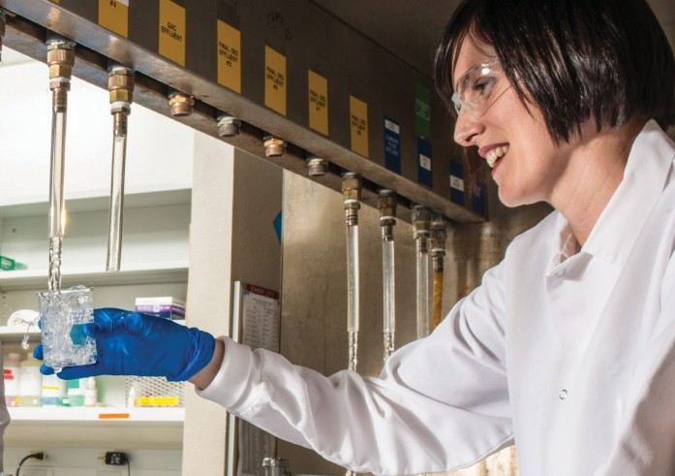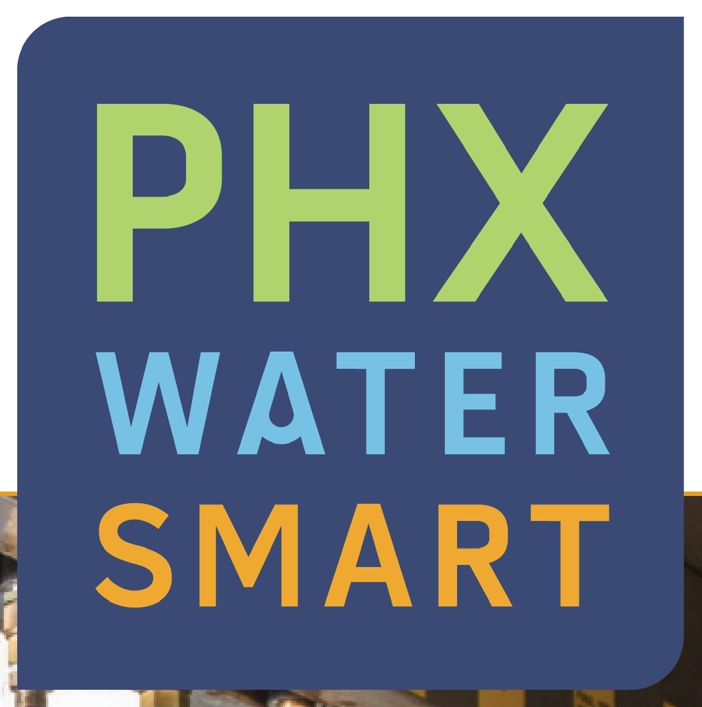

Tests Show No Cryptosporidium or Giardia in Our
Source Water Assessment Summary for the City Drinking Water Sources
assessment for the drinking water wells and the surface water sources for the city of Phoenix water treatment plants. This assessment reviewed the adjacent land uses that may pose a potential risk to the water sources. These risks include, but are not limited to, gas stations, landfills, dry cleaners, agricultural fields, wastewater treatment plants, and mining activities. Once ADEQ identified the adjacent land uses, they were ranked as to their potential to affect the water source.
The assessment has designated water from the Central Arizona Project (CAP) aqueduct to have a high risk because the source water is often stored in Lake Pleasant prior to being transported to a city water treatment plant. There have been reportable releases or spills of a substance at a facility near the lake that have not been reported as being remediated. The spill at this facility makes the CAP source water susceptible to potential future contamination.
Phoenix ensures the safety of your drinking water by continuously monitoring the treated water as required by drinking water regulations. Phoenix also conducts other monitoring and studies to assess water quality. If any contaminant approaches the drinking water MCL, treatment is installed or wells are removed from service.
Residents can help protect our water sources by practicing good septic system maintenance, taking hazardous household chemicals to hazardous material collection sites, and limiting pesticide and fertilizer use.
The complete report is available for review at ADEQ, 1110 W. Washington St., Phoenix, AZ 85007 or by requesting an electronic copy from ADEQ at dml@azdeq.gov.
For more information visit the ADEQ website at: http://www.azdeq.gov/node/735, or contact the Phoenix Water Services Department’s Environmental Services Division at 602-262-5012.
T
he Arizona Department of Environmental Quality (ADEQ) conducted a source water
Drinking Water

hoenix tests water for various microbiological organisms, including Cryptosporidium (often
P
called Crypto, for short) and Giardia. Crypto and Giardia cause diarrheal illness through ingestion of soil, food, water or surfaces that have been contaminated with feces from infected humans or animals. There were no cases of the disease caused by either organism attributed to the public water supply in our service area. Low levels of Giardia and
Crypto were found in raw water before it was treated
by the water treatment plants. Phoenix did not detect any Crypto in our finished water.

Under the Long Term 2 Enhanced Surface Water Treatment Rule (LT2ESWTR), EPA requires Phoenix and other large water systems to conduct monthly monitoring for Crypto in their source water. The LT2ESWTR results will determine if additional treatment is needed to remove these organisms. Phoenix monitored for Crypto at each water treatment plant from April 2015 until March 2017. Results range from not detected to 0.1 oocyst per liter of Crypto in the source water. Based on the monitoring results, Phoenix does not require any additional treatment. For more information about Cryptosporidium, Giardia and other microbial contaminants, contact the EPA’s Safe Drinking Water Hotline at 800-426-4791.
Internet sites that provide information about your drinking water
Arizona Department of Health Services
azdhs.gov
Maricopa County Environmental Services Dept. maricopa.gov/envsvc
U.S. Environmental Protection Agency
water.epa.gov/drink
Centers for Disease Control
cdc.gov
Arizona Department of Environmental Quality azdeq.gov
Tap Into Quality
tapintoquality.com

