2019 Annual Water Quality Report
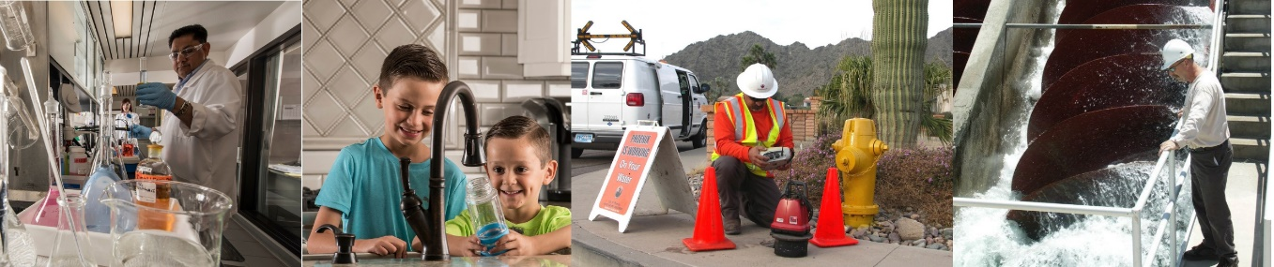

For Customers of the City of Phoenix-Anthem Water System

Drinking Water Safe Throughout 2019

About Your Water System:
Throughout 2019, tap water delivered to City of Phoenix customers west of Interstate 17 (I-17) and north of Daisy Mountain Drive, met or surpassed all federal and state drinking water standards. The City of Phoenix supplies you with water from the EPCOR Water Arizona Incorporated Anthem Water System east of I-17. EPCOR is required to provide high quality water that meets federal and state drinking water standards. Once the water reaches the Phoenix-Anthem Water System, the City of Phoenix Water Services Department maintains and assures high quality water by monitoring the distribution system and informing customers of any water quality issues. Phoenix is also responsible for providing this annual water quality report, which provides information about the water delivered to you.

Where Does My Water Come From?
Your water comes from several sources. Most of your water comes from Central Arizona Project (CAP) aqueduct, and is treated at the Anthem Water Treatment Plant. The main source of CAP water is from the Colorado River. However, some water from the Agua Fria River is mixed with Colorado River water during storage in Lake Pleasant. During times of high demand, EPCOR supplements the CAP supply with water from groundwater wells and water from the City of Phoenix Water System delivered east of I-17. For a broader picture of the EPCOR Water System, please contact EPCOR at 800-383-0834, or visit their website at www.epcor.com.

What’s In My Water?
EPCOR and the City of Phoenix Water Services Department conduct extensive monitoring to ensure that your water meets all water quality standards. During the past year, the water delivered to your home or business met or surpassed state and federal drinking water standards. Substances detected in the water and the Maximum Contaminant Level (MCL) allowed in the drinking water according to federal and state regulations are shown in the tables throughout this report. Definitions of terms used in this report can be found on the last page of the report. This report lists only the substances that were detected in the water. If you would like to receive a list of all the substances tested for, please contact the Phoenix Water Services Department’s Environmental Services Division at 602-262-5012. Please note, the presence of a substance or contaminant in drinking water does not necessarily indicate the drinking water poses a health risk.

To acquire this publication in an alternate format, contact PHX Customer Services at 602-262-6251, or 711 Telecommunications Relay Services.

Para obtener esta publicación en un formato alternativo, comuníquese con Servicios al Cliente al 602-262-6251 PHX, o 711 Servicio de Retransmisión

Substances Expected In Drinking Water

To ensure that tap water is safe to drink, the U.S. Environmental Protection Agency (EPA) prescribes regulations that limit the amount of certain contaminants in water provided by public water systems. The
  - Food and Drug Administration (FDA) regulations establish limits for contaminants in bottled water.

The sources of drinking water may include rivers, lakes, streams, ponds, reservoirs, springs, and wells. As water travels over the surface of the land or through the ground, it dissolves naturally-occurring minerals and, in some cases, radioactive material, and can pick up substances resulting from the presence of animals or from human activity. It is reasonable to expect drinking water, including bottled water or water that passed through home treatment systems, to contain at least small amounts of some contaminants. However, the presence of contaminants does not necessarily indicate that water poses a health risk. Contaminants that may be present in source water include the following:

    - Microbial contaminants, such as viruses and bacteria, that may be from wastewater treatment plants, septic systems, agricultural livestock operations or wildlife;

    - Inorganic contaminants, such as salts and metals, that can be naturally-occurring or result from urban storm water runoff, industrial or domestic wastewater discharges, oil and gas production, mining or farming;

    - Pesticides and herbicides, that may come from a variety of sources such as agriculture, urban storm water runoff and residential uses;

    - Organic chemical contaminants, including synthetic and volatile organic chemicals, that are byproducts of industrial processes and petroleum production and can also come from gas stations, urban storm water runoff and septic systems; and

    - Radioactive contaminants that can be naturally-occurring or can be the result of oil and gas production and mining activities.

More information about contaminants and potential health effects can be obtained by calling the U.S. Environmental Protection Agency’s Safe Drinking Water Hotline, 800-426-4791. Information on bottled water can be obtained from the FDA.

Special Health Information

Some people may be more vulnerable to contaminants in drinking water than the general population. Immuno-compromised persons such as persons with cancer undergoing chemotherapy, persons who have undergone organ transplants, people with HIV/AIDS or other immune system disorders, some elderly, and infants can be particularly at risk from infections. These people should seek advice from their health care providers about drinking water. The EPA and the Centers for Disease Control (CDC) guidelines on appropriate means to lessen the risk of infection by Cryptosporidium and other microbial contaminants are available from the EPA Safe Drinking Water Hotline (800-426-4791).

2019 Detected Regulated Substances at Point Where Water Leaves the Anthem Treatment Plant
Substance | Units | MCL | MCLG | Lowest  Level | Highest  Level | Typical Source of Substance
*Arsenic | ppb | 10 | 0 | 2 | 3 | Erosion of natural deposits; Runoff from orchards;  Runoff from glass and electronics production wastes
*Barium | ppm | 2 | 2 | 0.1 | 0.1 | Discharge of drilling wastes; Discharge from metal  refineries; Erosion of natural deposits
*Fluoride | ppm | 4 | 4 | 0.4 | 0.4 | Erosion of natural deposits; Water additive which  promotes strong teeth; Discharge from fertilizer and aluminum factories
Nitrate | ppm | 10 | 10 | 0.2 | 3.2 | Runoff from fertilizer use; Leaching from septic tanks, sewage; Erosion of natural deposits
*Selenium | ppb | 50 | 50 | ND | 3 | Discharge from petroleum and metal refineries;  Erosion of natural deposits; Discharge from mines
**Alpha Emitters | pCi/L | 15 | 0 | 4 | 4 | Erosion of natural deposits
**Combined Radium | pCi/L | 5 | 0 | 0.4 | 0.4 | Erosion of natural deposits

*2018 Monitoring- Some of our data, though representative, are more than a year old. The state of Arizona allows us to monitor for some contaminants
less than once per year because the concentrations of these contaminants do not change frequently.

**2014 Monitoring- Some of our data, though representative, are more than a year old. The state of Arizona allows us to monitor for some contaminants
less than once per year because the concentrations of these contaminants do not change frequently.

The Anthem Water Treatment Plant produces water of superior clarity through filtration. Turbidity readings are a measure of water clarity and a good indicator that the treatment process is removing tiny particles, including microorganisms. The standard for turbidity or clarity after treatment cannot be greater than 1 Nephelometric Turbidity Units (NTU – a measure of clarity). In at least 95 percent of the measurements taken each month, the turbidity must not exceed 0.3 NTU. The corresponding chart shows that the water you received in 2019 met the requirements.

2019 Turbidity Monitoring after Treatment at the Anthem Water Treatment Plant
Substance | Treatment Technique Applies instead of MCL | MCLG | Highest Measurement | Lowest Monthly Percentage | Typical Source
Turbidity | No value can exceed 1 NTU and at least 95% of monthly measurements must be less than or equal to 0.3 NTU | NA | 0.1 NTU | 100% of measurements met treatment technique | Soil runoff

Monitoring Conducted by the City of Phoenix within the Phoenix-Anthem Water System

The City of Phoenix monitors the Phoenix-Anthem water distribution system for both chlorine disinfectant levels and for total coliform bacteria which can indicate the presence of disease-causing organisms.

2019 Microbiological Monitoring in the Distribution System
Substance | MCL | MCLG | E. coli MCL Violation | Typical Source
Total Coliform Bacteria | Treatment Technique  (Level 1 or Level 2 Assessment) | NA | NA (Level 1 or Level 2 assessment not required) | Naturally present in the environment
E. coli Bacteria | Routine and repeat samples are total coliform-positive and either is E. coli-positive or system fails to take repeat samples following E. coli-positive routine sample or system fails to analyze total coliform-positive repeat sample for E. coli. | 0 | No violation  Zero (0) E. coli detected | Human or animal fecal waste

Your drinking water is safely disinfected with chlorine to prevent widespread outbreaks of serious diseases and comply with EPA standards. Federal law requires a minimum chlorine disinfectant level of 0.2 ppm in the water leaving a water treatment plant. There also is a Maximum Residual Disinfectant Level (MRDL) of 4 ppm allowed in the water in the distribution system as it travels to your tap. While it is essential to disinfect the water, the use of disinfectants can create disinfection byproducts (DBPs). To determine formation of DBPs, the City of Phoenix monitors the Phoenix-Anthem Water System for Total Trihalomethanes (TTHMs) and Haloacetic Acids (HAAs) which are DBPs that may cause long- term health effects at certain concentrations. TTHMs and HAAs are sampled throughout the Phoenix-Anthem distribution system every quarter. The table below includes the locational running annual averages (LRAA) compliance data for TTHM and HAA. The LRAA for all samples collected at the monitoring locations were below the MCL.

2019 Disinfectant and Disinfection Byproduct Monitoring in the Distribution System
Substance | Units | MCL | MCLG | Lowest Level | Highest Level | Highest Running Annual Average | Major Source in Drinking Water
Chlorine | ppm | MRDL= 4 Running Annual Average | MRDLG=4 | <0.2 | 1.7 | 0.8 | Water additive used to control microbes
Total Trihalomethanes (TTHM) | ppb | 80 Locational Running Annual Average | NA | 11 | 57 | 35 | Byproduct of drinking water disinfection
Haloacetic Acids (HAA) | ppb | 60 Locational Running Annual Average | NA | 1 | 6 | 4 | Byproduct of drinking water disinfection

2019 Aesthetic Water Quality Analysis from Distribution System and Secondary
Drinking Water Guidelines
Substance | Units | Secondary  Guideline* | Lowest Detected  Level | Highest Detected  Level
Alkalinity | ppm | NA | 132 | 188
pH | NA | 6.5 – 8.5 | 7.3 | 8.0
Sodium | ppm | NA | 44 | 99
Temperature | °F | NA | 65 | 90
Total Dissolved Solids (TDS) | ppm | 500 | 538 | 636
Total Hardness | ppm  (grains/gallon) | NA | 279  (16) | 315  (18)
*Non-Enforceable Guidelines Recommended by EPA.

Unregulated substances are those for which EPA has not established drinking water standards. Phoenix monitors for these substances to assist the EPA in determining the occurrence of unregulated contaminants in drinking water and whether future regulation is warranted. The EPA issues a new list of up to 30 unregulated substances for monitoring every five years.
EPA identified 30 substances for monitoring during this five-year cycle including:

- 9 cyanotoxins and 1 cyanotoxin group which are toxins produced by a bacteria called cyanobacteria.
- 2 metals that occur naturally in our environment
- 8 pesticides and 1 pesticide manufacturing byproduct
- 3 disinfection byproduct groups that can be formed during water treatment and distribution
- 3 alcohols
- 3 semivolatile organic chemicals

UCMR4 samples were collected at entry points to the distribution system for all contaminant groups except for the HAAs which had been taken in the distribution system.

From April of 2018 through January of 2019 the City was monitoring for unregulated substances within the Phoenix-Anthem distribution area. Any unregulated contaminants detected are reported in the following table. If the EPA determines that regulation is warranted for any of the monitored substances, Phoenix will take whatever steps that are necessary to comply with the new requirements.

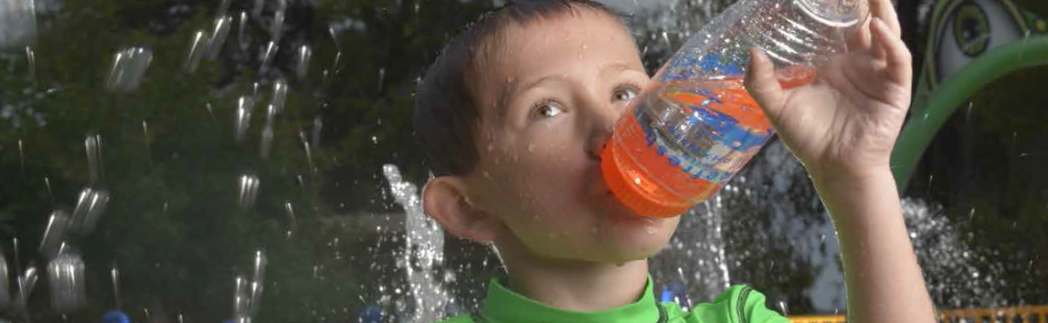

Unregulated Contaminants Monitoring within the Distribution System
Substance | Units | MCL | Lowest Level | Highest Level | Average | Major Source in Drinking Water
Manganese | ppb | None | 0.8 | 6 | 3 | Naturally-occurring element
HAA6Br | ppb | None | 3 | 17 | 8 | Byproduct of drinking water disinfection
HAA 9 | ppb | None | 4 | 30 | 13 | Byproduct of drinking water disinfection

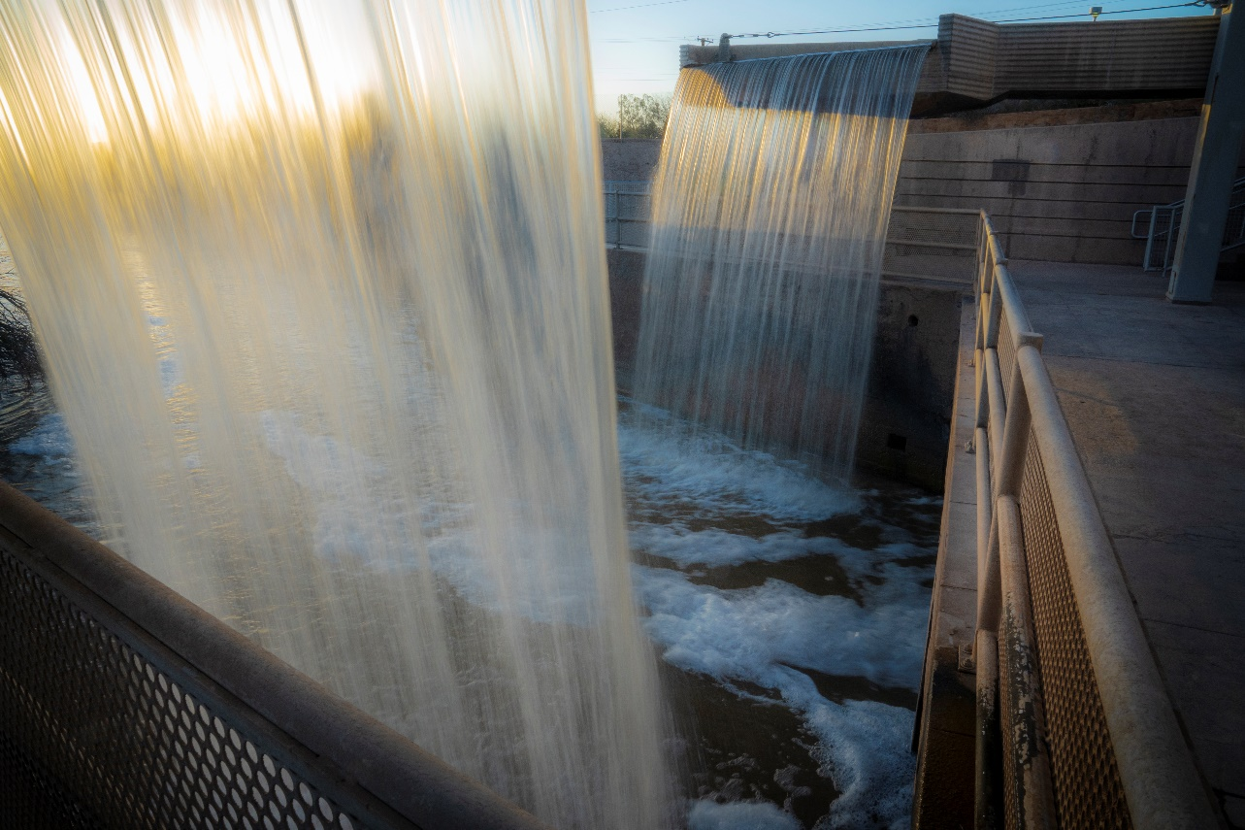

Lead and Copper Standards Met

The primary source of lead and copper in drinking water is from corrosion of household plumbing and fixtures that contain these metals such as copper piping, lead solder or brass fixtures. The EPA requires water suppliers to perform periodic tests for lead and copper in the tap water from inside consumer’s homes. Tests show levels in the City of Phoenix-Anthem household tap water met the Action Level required by federal drinking water standards for lead and copper.

While the City of Phoenix-Anthem water system meets the Action Level, lead and copper levels at some consumer’s homes may be elevated due to leaching of the metals into the water from materials used in the household plumbing or fixtures. If present, elevated levels of lead can cause serious health problems, especially for pregnant women and young children. Lead in drinking water is primarily from materials and components associated with service lines and home plumbing. The City is responsible for providing high quality drinking water, but cannot control the variety of materials used in plumbing components. When your water has been sitting for several hours, you can minimize the potential for lead exposure by flushing your tap for 30 seconds to two minutes before using water for drinking or cooking. If you are concerned about lead in your water, you may wish to have your water tested. Information on lead in drinking water, testing methods, and the steps you can take to minimize exposure is available from the Safe Drinking Water Hotline or at water.epa.gov/drink/info/lead.

Lead and Copper Sampling from Water Taps in 2017*
Substance | Action Level (AL) Applies instead of MCL | MCLG | 90 percent of taps were less than or equal to this value | Number of sites above the AL | Typical Source
Lead | 90% of taps tested must not exceed 15 ppb | 0 ppb | 2 ppb | Zero (0) out of 21 taps | Corrosion of Household plumbing systems
Copper | 90% of taps tested must not exceed  1.3 ppm | 1.3 ppm | 0.7 ppm | Zero (0) out of  21 taps | Corrosion of Household plumbing systems
*2017 Monitoring- Some of our data, though representative, are more than a year old. The state of Arizona allows us to monitor for some contaminants
less than once per year because the concentrations of these contaminants do not change frequently.

Source Water Assessment for Drinking Water Sources
The Arizona Department of Environmental Quality completed a source water assessment for the wells and one surface water intake used by the EPCOR. The assessment reviewed the adjacent land uses that may pose a potential risk to the sources. These risks include, but are not limited to, gas stations, landfills, dry cleaners, agricultural fields, wastewater treatment plants, and mining activities. Once ADEQ identified the adjacent land uses, they were ranked as to their potential to affect the water sources. The results of the assessment were that the wells had no adjacent land uses in the vicinity of the wells, and that the surface water intake had one adjacent land use that posed a high risk to the source.

ADEQ also conducted a source water assessment for the City of Phoenix drinking water wells and the surface water intakes used by the Phoenix water treatment plants. The same surface water intake identified in the EPCOR source water assessment was also identified for the Phoenix source water assessment report.

The sources are currently protected by well construction and system operations and management. Residents can help protect sources by taking hazardous household chemicals to hazardous material collection days and limiting pesticide and fertilizer use.

The complete reports are available for review at ADEQ, 1110 W. Washington St., Phoenix, Arizona, 85007; or by requesting an electronic copy from ADEQ at recordscenter@azdeq.gov. For more information, visit the ADEQ website at: http://www.azdeq.gov/node/735, or contact Director of Compliance at EPCOR, 623-445-2406 or the Phoenix Water Services Department Environmental Services Division at 602-262-5012.

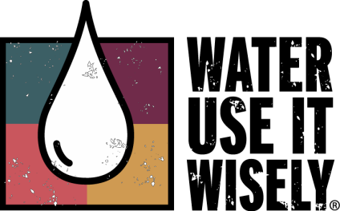
How Can I Learn More?

Customers with questions about the water you receive from EPCOR may email watersmart@phoenix.gov or call the Phoenix Water Services Department Environmental Services Division at 602-262-5012 during normal business hours (Monday through Friday, except holidays, from 7:30 a.m. to 4:00 p.m.) or write to: Water Quality Questions, City of Phoenix Water Services Department, Environmental Services Division, 2474 S. 22nd Avenue, Building 31, Phoenix, AZ 85009.

Citizens who wish to address the Phoenix City Council about water issues or other non-agenda items may do so at the Citizen Request Sessions at City Council Formal Meetings, which are held in the City Council Chambers, 200 W. Jefferson Street, Phoenix, AZ 85003. For information about specific meeting times and agenda items, please contact the City of Phoenix City Clerk Department at 602-262-6811 or visit Phoenix.gov and click on Mayor/City Council, view Council Meetings and Agenda.

For alternate formats, contact Customer Services at 602-262-6251/Voice, or 711 for Telecommunications Relay Service. You also may call the EPA’s Safe Drinking Water Hotline for information about the Safe Drinking Water Act or EPA’s other drinking water programs at 800-426-4791.

Websites that Provide Information about Drinking Water

Arizona Department of Health Services – azdhs.gov

  - Maricopa County Environmental Services Department – maricopa.gov/envsvc

  - U.S. Environmental Protection Agency – water.epa.gov/drink

  - Centers for Disease Control – cdc.gov

  - Arizona Department of Environmental Quality – azdeq.gov

  - Tap Into Quality – tapintoquality.com

  - Arizona Water Quality Association – azwqa.org

Water Conservation Tips

For 100 ideas to help you save water, visit:

www.wateruseitwisely.com

For additional information on water conservation or to order free literature, visit: Phoenix.gov/BeWaterSmart

Definition of Terms

The following are definitions of terms used to describe types of limits for substances that may be found in drinking water.

Action Level (AL) – The concentration of a contaminant which, if exceeded, triggers treatment or other requirements which a water system must follow.

Maximum Contaminant Level (MCL) – The highest level of a contaminant that is allowed in drinking water. MCLs are set as close to the MCLGs as feasible using the best available treatment technology.

Maximum Contaminant Level Goal (MCLG) – The level of a contaminant in drinking water below which there is no known or expected risk to health. MCLGs allow for a margin of safety.

Maximum Residual Disinfectant Level (MRDL) – The highest level of a disinfectant allowed in drinking water. There is convincing evidence that addition of a disinfectant is required for control of microbial contaminants.

Maximum Residual Disinfectant Level Goal (MRDLG) – The level of drinking water disinfectant below which there is no known or expected risk to health. MRDLGs do not reflect the benefits of the use of disinfectants to control microbial contaminants.

Part per million/part per billion – One part per million (1 ppm) or one milligram per liter (1 mg/L) is approximately equal to a single penny in $10,000 or one minute of time in two years. One part per billion (1 ppb) or one microgram per liter (1 µg/L) is approximately equal to a single penny in $10,000,000 or one minute of time in 1,920 years.

Picocuries per liter (pCi/L) – A measure of radioactivity.

Treatment Technique (TT) – A required process intended to reduce the level of a contaminant in drinking water.

Locational running annual average (LRAA) - The average of analytical results for samples taken at a particular monitoring location during the previous four calendar quarters.

NA – Not Applicable

ND – Not Detected (substance was analyzed but not detected)

Connect With Us: Phoenix.gov/Water

Twitter: @PHXWater Instagram: /PHXWater Facebook: /PHXWater

